Post Bariatric Surgery Diet

This weight loss surgery will provide you with the ability to eat smaller amounts of food. It is a tool for weight loss and there are recommendations that MUST be followed to make this operation a success.

It is important to remember that changes are necessary in your diet. You will have to eat foods rich in nutrients because of the small portions you will hold. BEHAVIOR MODIFICATIONS are essential for losing and maintaining weight.

We encourage you to set goals outside of your weight, as these can encourage long-term success.
- “I want to play basketball with my grandkids.”
- “I want to be able to walk a 5K.”
- “I want to try new, healthy foods to nourish my body.”

General Guidelines for the Diet:

- Eat 6 times a day- Consume high protein, nutritious meals every 2-3 hours
- You will start with ¼ cup portion for each meal and advance to ½ cup portion in the first 6 months. Eventually, you will eat ~1 cup 6x/ day
- Clear liquid diet while in hospital
- Full liquid diet: 1 day post op – 1 week post op – meals will be dairy or soy milk products, high protein soups or gelatins, and protein supplements
- Chopped diet: 1 week post op – 1 month post op – foods must be chopped with liquid added (broth or fat-free/low-fat, no/low sugar condiment) or be applesauce consistency
- Soft diet: 1 month – 2 months post-op– keep foods moist and soft
- Solid diet: 2 months post-op and beyond– protein first at every meal

- Protein
- You must eat enough protein daily to maintain your nutritional status.
- Good protein sources
    - lean meats- chicken, turkey, fish, seafood, pork, beef
    - low fat/fat free, no added sugar dairy products- milk, cottage cheese, yogurt, cheese
    - low fat, no added sugar soy products
    - Eggs/egg whites
    - Nuts/nut butters
    - Beans/legumes
    - Protein supplements
- Protein must be eaten first at every meal.
- You will eat strictly protein in the beginning months because of the small portions you will hold.

- Fluids
- You MUST sip slowly after surgery.
- Drink 64 oz of fluid daily to prevent dehydration and constipation.
- No liquids 20-30 minutes before, during, or 20-30 minutes after your meals.
- No carbonation or alcohol
- Limit caffeine
- Straws- case by case basis
- Consume only water and/or sugar-free, non-carbonated beverages.
    - Crystal Light, Minute Maid Light, Diet Lipton Tea, decaf tea and coffee, broth, sugar-free gelatin, and sugar-free popsicles

- Supplements
- Different vitamin/mineral regimens for surgery type
- Additional vitamins may be required depending on lab work
- Lifelong commitment
- You do not need any additional “hair, skin, and nail” vitamins.

- Behavior modifications
- Take small bites
- Chew to applesauce consistency
- Put fork/spoon down in between bites
- Pay attention at mealtime
- Stop eating or drinking when you feel full. Symptoms of fullness include vomiting, pressure in the center of the ribcage, pain in the upper chest or discomfort in the lower esophagus or left shoulder.
- Sit in upright position and/or go out walking after eating to help prevent reflux or to alleviate gas pressure.

- Eat healthy
- Avoid foods that can cause discomfort- spicy, gassy, and/or acidic foods
- Avoid simple sugars
  - Table sugar, syrup, jelly, jam, honey, fruit juice, sodas, cakes, cookies, ice cream, candy, and sugar alcohols (found in some sugar-free foods)
- Avoid high fat and refined carbohydrate foods
    - Fried foods, butters, oils, salad dressings, whole milk products
    - Starches (bread, pasta, rice, cereals, and crackers) made with white flour
- Read food labels
- Keep fat calories 25% or less
- Vegetables, fruits, and whole grains will be added to diet slowly to achieve a balanced diet

- Progress your diet SLOWLY. – You may experience some intolerance to certain foods.

- Dumping Syndrome- Most commonly occurs with Roux-en-Y gastric bypass.
- Early dumping syndrome occurs when a sugary food or beverage is consumed and the intestines must dilute the high concentration of sugar by drawing in extra fluid into it. This intestinal distention results in nausea, dizziness, weakness, rapid pulse, cold sweats, and diarrhea 10-30 minutes after eating.
- Late dumping syndrome occurs when a rapid absorption of glucose causes a large amount of insulin to be released, causing low blood sugar. Symptoms of low blood sugar are shaking, sweating, irritability, and confusion. This occurs 1-3 hours after eating.
- Preventing Dumping Syndrome:
  - Avoid juice, soda, frosting, and other concentrated sweets
  - Avoid added sugars, including honey, agave nectar, and high fructose corn syrup
  - No need to avoid natural sugars, such as those found in fruit and dairy
  - Choose high fiber carbohydrates
  - Pair those carbohydrates always with a protein or fat
  - Do not consume liquids with or 20-30 minutes outside your meals/snacks
Serving size reflects the amount that people typically consume. It is not a recommendation of how much to eat or drink. On this nutrition facts label, if you ate 2 cups, you would be eating 2 servings and would need to double everything on the nutrition facts label.
If you consumed the whole container, you ate 4 servings and would need to multiply everything on the nutrition facts label by 4.

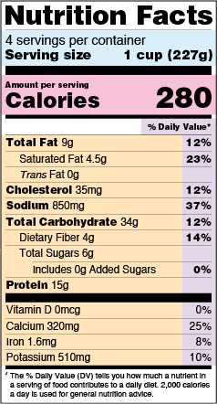
Aim for 15 grams of fiber for every 800-1,000 calories consumed. Good sources of fiber are fruits, veggies, whole grains, beans, and legumes.
You will be getting a protein goal. Make sure that every meal AND snack has a good source of protein with it.
Good- unsaturated fat
Limit- saturated fat
No- trans fat/hydrogenated oils
All fat has 9 calories per gram.
Aim for 5 grams of sugar or less per serving. Drinks should have 1 gram of sugar or less. Milk and fruit have natural sugar in them but should not have added sugars. Honey, table sugar, corn syrups, and brown sugar are all added sugar. Single ingredient sugar labels are not required to include a declaration of number of grams of added sugar.

Sample Menu for Full Liquid Diet:
1 day-1 week after surgery

Breakfast – ¼ cup skim milk with protein powder

Mid Morning – ¼ cup fat-free, no added sugar yogurt

Lunch – ¼ cup low fat cottage cheese

Mid Afternoon – ¼ cup low fat cream soup made with low-fat milk

Dinner – ¼ c broth with protein powder

Late Evening – ¼ cup sugar-free, fat-free pudding
In between meals, you may have sugar-free popsicles, sugar-free gelatin, protein supplements, sugar-free, non-carbonated beverages, and water.

Sample Menu for Chopped Diet:
1 week-1 month after surgery

Breakfast – ¼ cup skim milk with protein powder

Mid Morning – ¼ cup fat-free, no added sugar yogurt

Lunch – ¼ cup chopped chicken

Mid Afternoon – ¼ cup low fat cottage cheese

Dinner – ¼ cup chopped tuna salad

Late Evening – 1 Tbsp creamy peanut butter

In between meals, you may have sugar-free popsicles, sugar-free gelatin, protein supplements, sugar-free, non-carbonated beverages, and water.

Sample Menu for Soft Diet:
1 month-2 months after surgery

Breakfast – 1 scrambled egg white

Mid Morning – ¼ – ½ cup fat-free, no added sugar yogurt

Lunch – ¼ cup chicken salad

Mid Afternoon – 1 oz of reduced-fat cheese

Dinner – 1-2 oz lean meat

Late Evening – 1 Tbsp creamy peanut butter

In between meals, you may have sugar-free popsicles, sugar-free gelatin, protein supplements, sugar-free, non-carbonated beverages, and water.

Sample Menu for Solid Diet:
Starting 2 months after surgery

Breakfast – 1 scrambled egg w/ 1 oz diced ham

Mid Morning – ½ - 1 oz almonds

Lunch – ¼ - ½ c fat-free refried beans w/ ½ whole wheat tortilla

Mid Afternoon – 1 oz of reduced-fat cheese w/ 2-3 whole wheat crackers

Dinner – 2-3 oz lean meat w/ ¼ c mixed vegetables

Late Evening – 2-3 oz lean deli meat w/ ¼ c unsweetened applesauce

In between meals, you may have sugar-free popsicles, sugar-free gelatin, protein supplements, sugar-free, non-carbonated beverages, and water.

*As you progress your diet, you will add to these protein sources. Eventually, you will eat vegetables, fruits, and whole grains, but protein will always be the emphasis of your diet.

Resources

- Support Groups
  - Unjury
  - ProCare Health
  - Bariatric Fusion
- Nutrition Tracking
  - My Fitness Pal
  - Bitesnap
  - Yazio
  - Cronometer
  - Calory
  - Lose It!
- Eating Patterns & Mindfulness
  - 20 Minute Eating
  - Am I Hungry
  - Headspace
  - Ate Food Journal

- Bariatric Specific
  - Baritastic
  - Waterlogged
  - Happy Scale
- Meal Planning and Recipes
  - Eat This Much
  - Paprika
  - eMeals
  - Mealime
  - Platejoy
  - Bariatric Food Coach
- Recipes
  - www.celebrate.com
  - www.unjury.com
  - www.bariatricfusion.com
  - https://issuu.com/asmbsfoundation.org/docs/6725_treo_cookbook_2023_02

Behavior modification goal

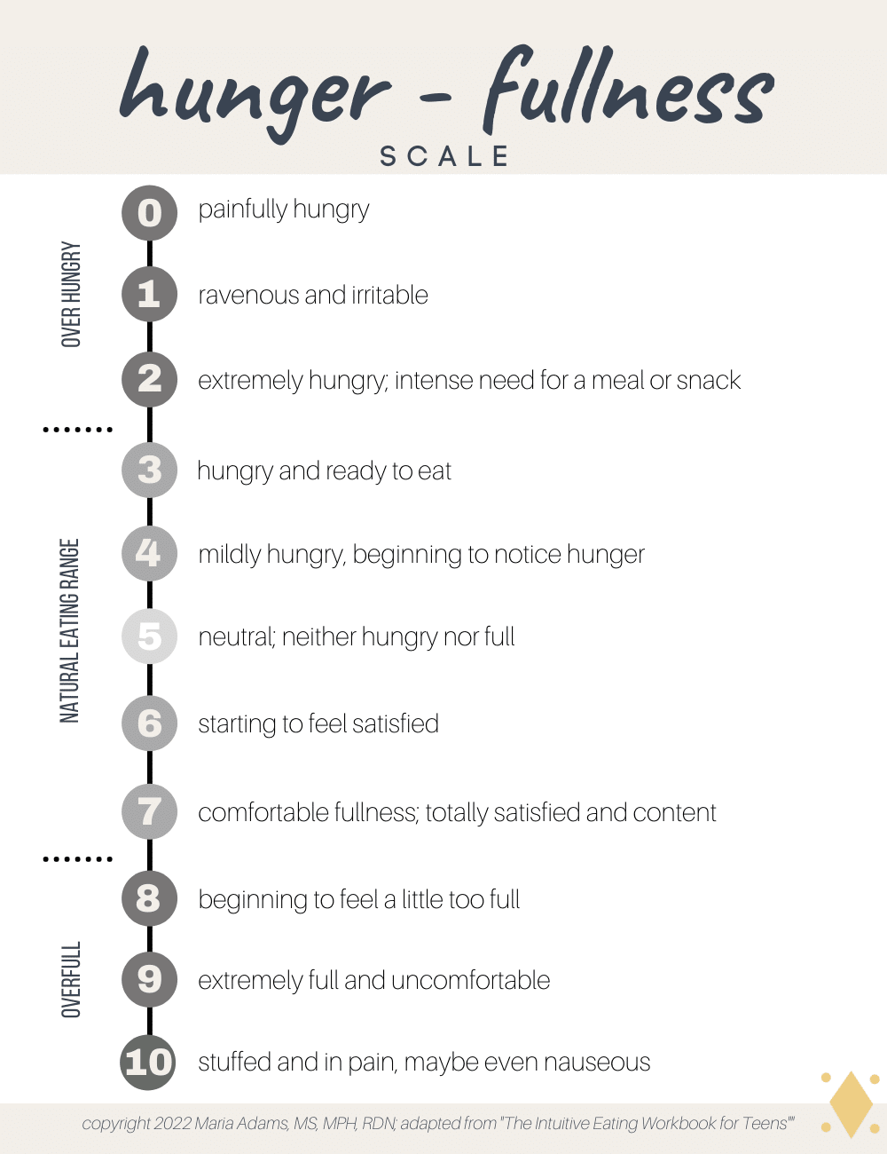
- Follow a structured eating pattern
- Practice mindful eating
- Use smaller plates (7-9 inch in diameter)
- Avoid drinking with meals
- Self-monitor eating and physical activity
- Develop awareness of physical hunger and satiety

Nutrition goals

- Decrease/eliminate eating out
- Eliminate calorie containing beverages
- Decrease processed foods and added sugars
- Focus on increasing intake of lean protein foods, whole fruits and vegetables, and changing to whole grains
- Drink 64 oz of no- or low- calorie fluids throughout the day

